Loki Research, an Alternate Choice in Motors
Based on the number of questions I fielded during the April high power launch, I thought I’d write a quick article on Loki Research motors and highlight some of the reasons you might want to consider using them. The question that was asked most often, was “Why Loki?” That’s a pretty simple question that has a slightly complex answer. To answer this, I will cover what I consider to be the pros for Loki motors, as well as the cons. For the purposes of this article, I will limit motor considerations to two, 38 and 54 mm, which are more suitable for our current fields in Frisco and Gunter.
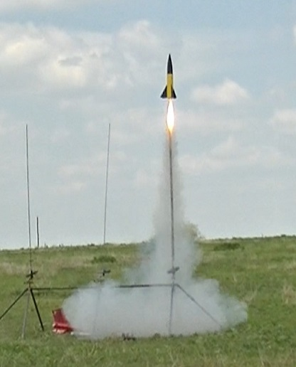
Loki G80 White in a scratch built 3” rocket
First, let’s discuss the positives. Probably the most valuable benefit of Loki motors is the number of loads that can be shipped without a Hazmat fee. All of the 38/120, 38/240 and half of the 38/480 loads can ship standard surface mail with no Hazmat fee. This covers motors ranging from G to I, and can be a huge benefit if you are not placing an order with a large number of motors to spread the $28.50 fee across. (Of course, if you are purchasing an AeroTech motor from our new on-site vendor, the Hazmat question is moot. I recommend supporting our local vendors, when possible.) If you are purchasing a CTI motor, this is an important consideration. Another benefit is the ease of assembly, at least compared to AeroTech. The motors are very easy to put together and utilize only 2 sizes of O-rings, so you don’t have to worry about putting the wrong one in the wrong location causing a failure. This will be covered in more detail later. Cost per reload is another area that Loki Research shines, especially compared to CTI. The table below shows price comparisons for comparable size loads for Loki, AeroTech and CTI.
RELOAD PRICE COMPARISON
Loki | AeroTech | CTI
38/120 - $16.50* | 38/120 - $18 | Pro 38 -1 - $24
38/240 - $25* | 38/240 - $24 | Pro 38 -2 - $32
38/480 - $40* | 38/480 - $47 | Pro 38 -4 - $48
38/740 - $52 | 38/720 - $58 | Pro 38 -6 - $63
54/1200 - $75 | 54/1280 - $93 | Pro 54 -2 - $73
54/2000 - $110 | 54/1706 - $113 | Pro 54 -4 - $113
54/2800 - $165 | 54/2560 - $153 | Pro 54 -6 - $153
*USPS shipping
Hardware costs for 38mm motors are higher compared to CTI, but are quite a bit lower than AeroTech/Rouse-Tech for similarly sized cases. However, the cost of the reloads quickly makes up for the price difference in the hardware. Once you have purchased 3-5 motors for a given case, you have made up the difference in the hardware cost. When accounting for the Hazmat fee, one motor is enough to make up the difference. For 54mm, CTI is far less expensive than Loki or AeroTech. That said, Loki hardware is second to none in quality. The 54mm cases are drawn-over-mandrel (DOM) tubing, which provides tighter specs than pipe tubing and less machining to bring the raw material into final shape. With raw material at the needed dimensions, the only machining that really needs to be done is to cut the grooves for the retaining rings and chamfer the ends of the case. Less processing allows for helping offset some of the costs of DOM tube and provides extremely consistent products. The machining is first-rate and the anodizing is beautifully done. With the low profile thrust ring on current production cases, Loki cases fit most all motor retainers, including the Slimline retainers, with the exception of the 54/2800.
HARDWARE PRICE COMPARISON
Loki | AeroTech/Rouse-Tech | CTI
38/120 - $60 | 38/120 - $86 | Pro 38 -1 - $28
38/240 - $70 | 38/240 - $96 | Pro 38 -2 - $33
38/480 - $80 | 38/480 - $110 | Pro 38 -4 - $46
38/720 - $90 | 38/720 - $116 | Pro 38 -6 - $57
54/1200 - $140 | 54/1280 - $145 | Pro 54 -2 - $64
54/2000 - $160 | 54/1706 - $180 | Pro 54 -4 - $92
54/2800 - $180 | 54/2560 - $222 | Pro 54 -6 - $112

The most important pro to me is that Loki Research is truly a David competing against Goliaths. Loki Research is run by Scott Kormeier, who is the one and only employee. With rocketry being a relatively small, niche hobby, having more, viable vendors is extremely important, and a challenge for the smallest of them. Supporting the little guys makes rocketry stronger by providing more options and keeping them all innovating new products. Also, the level of service Scott provides sets the standard for the industry. He has over 20 years of customer service experience. He has invested quite a bit of time and effort to source all of his raw materials from US sources, and improve the quality and consistency of Loki products.
One last pro, is that the snap ring style cases are basically a requirement for research motors. This is vital for those who are interested in that branch of rocketry. While there are other snap ring cases out there, since Loki cases fit motor retainers with little difference from AeroTech or CTI, one rocket can fly commercial loads as well as research loads which adds even more dollar value to Loki Research hardware.
As I mentioned earlier, ease of use is one of the strong suits of a Loki motor. The hardware consists of 3 major parts – the case, the nozzle and the bulkhead, with 2 snap rings and a stainless steel washer rounding out the parts bill. A 38mm reload is made up of 2 large O-rings, 6 smaller delay grain O-rings, a liner, the proper number of grains (1-8 depending on the reload), the delay grain, and the ejection charge. The 54mm motors omit the ejection charge and have a tracking grain with a single O-ring in place of the delay grain and 6 O-rings. Assembly of a 38mm motor takes approximately five minutes, although Scott says it takes him about half that. The description below makes it sound far more complicated than reality. Scott has an excellent video available on YouTube for both the 38mm and 54mm motors.
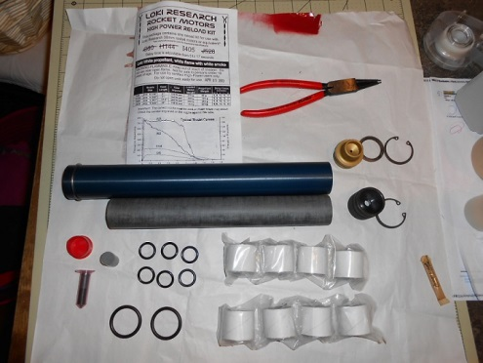
Contents of an I405 White reload with the 38/740 hardware
- Grease all O-rings. I use Super Lube or synthetic disc brake grease. Other alternatives are Dow 111, Vaseline, or other similar greases. Remember, all you need is a light sheen on the O-rings. Big globs of grease are to be avoided.
- Before you clean your hands, rub a light coating of grease on the inside of the case, only at the ends inside the snap ring grooves (see picture). Also rub a thin layer of grease on the inside of the delay bulkhead.
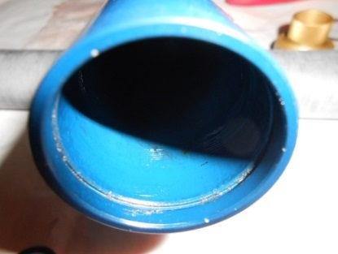 snap ring groove
- Place one large O-ring in the groove on the nozzle, and one in the groove on the bulkhead.
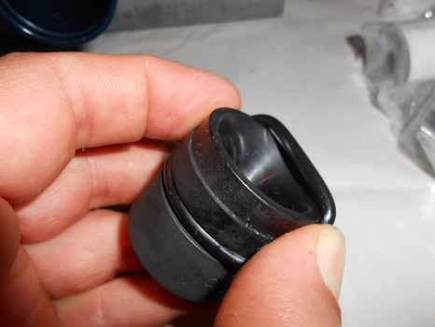
- Clean your hands of any grease. I highly recommend baby wipes.
- Load the grains into the liner.
- Place the nozzle into the liner, making sure the shoulder of the nozzle slips into the liner.
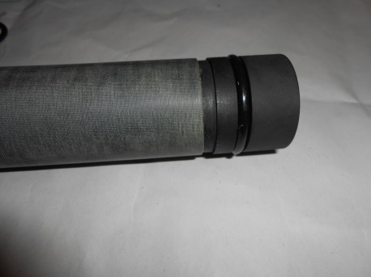
- Slide the case over the nozzle/liner assembly until the nozzle O-ring slips past the snap ring groove.
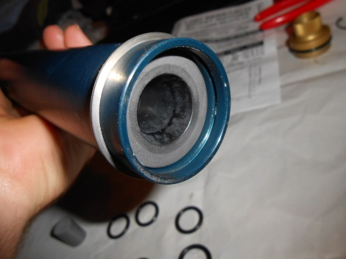
- Stack the delay O-rings on the delay grain. This is easiest done by pushing the delay grain down into the center of the delay O-rings one-by-one. Once done, leave the delay
grain with O-rings standing on the table and press the bulkhead onto the delay grain.
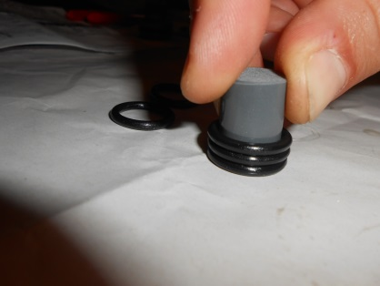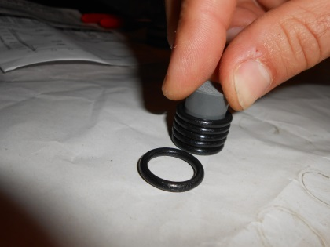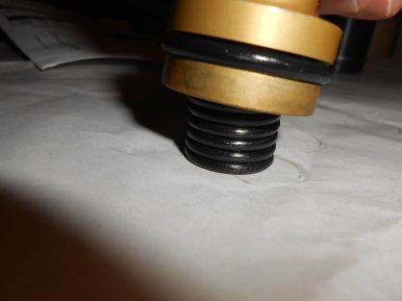
- Using a Loki/CTI-DAT tool, adjust the delay to the time needed. Alternatively, use a ¼” drill to remove 1/32” for each second of delay. Per the reload instructions, do not remove more than 3/8”.
- Press the bulkhead into the case, below the groove for the snap ring. Add the top snap ring.
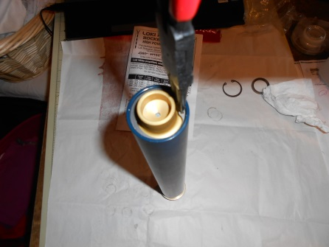
- Turn the motor over, and press the nozzle in until it stops. Add the nozzle washer and remaining snap ring.
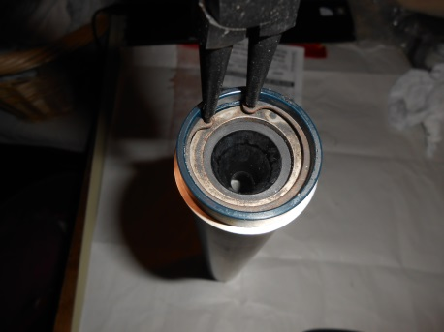
- When ready to fly, add the provided ejection charge and cap (38mm only).

Cleaning is almost as easy. The only real change from any other motor is cleaning the nozzle, since this gets reused on these motors.
- Allow the motor to cool enough to handle.
- Remove the snap rings, push out the nozzle and spent liner using the bulkhead, then push out the bulkhead. I use a 1” dowel for this.
- Wipe down the case and bulkhead using a baby wipe.
- Using a non-marring tool (small screwdriver, bamboo skewer) remove the O-rings from the bulkhead and nozzle.
- Wipe the nozzle with a dry paper towel. Most of the slag from the motor firing will come off with this wipe. Clean the nozzle throat using the paper towel and a small dowel. If needed, a razor blade and a small jeweler’s screwdriver can be used to gently pry the slag from the surface of the nozzle, both entrance cone and throat. To do this, carefully work a corner of the blade under the edge of the slag. Slowly work around the nozzle lifting the ring of slag as you go. Be careful not to scratch or gouge the nozzle. If this happens, a quick (and gentle) rub with 600 then 1500 grit sand paper can be used to smooth the nozzle surface.

I know what you’re thinking - these things sound like the best thing since sliced bread, so what’s the catch? There are a few minor negatives to the Loki motors, and by sheer count, it would appear they outweigh the positives. However, none of the items I count as negatives are serious, and some are in the process of being alleviated.
As mentioned in the use and cleaning, the nozzle for these motors has to be cleaned after each firing in order to reuse it. However, this is making a mountain out of a molehill. The residue left by the white and blue motors is cleaned with a quick wipe of a paper towel. My first thought after cleaning a nozzle after firing these motors was “Wait, I must not be cleaning well enough. That was too easy.” Red motors can leave a bit of slag to contend with, but only takes a few extra minutes to clean. The Spitfire motors (sparky type) are apparently the worst, but since these are not likely motor selections for our current fields, I have no experience with cleaning this particular kind of motor residue.
Since the nozzles are reused, they will wear out and must be replaced. The nozzle will last 10-25 firings, per the Loki Research website. When the throat erodes 1/64” (.016”) past its original diameter, it can no longer be used for the given case. This is best measured with a pair of calipers with extended jaws, a set of pin gages, or a telescoping plug gage. For those of you who don’t have access to one of these, a drill bit will allow for a decent eyeball approximation. At this point, the nozzle can be returned to Loki for refurbishment. What this means, is that the throat will be bored to the next larger size, so you will end up with an almost new nozzle for the next size case (i.e., 38mm #10 nozzle bored to #16. This nozzle can no longer be used for the 38/120 case, but can be used for the 38/240 or 38/480 case.)
Another, less frequent, failure mode for the nozzles is cracking. This is typically caused by pieces of the casting tube being spit at the end of the burn which is more common with research reloads, or by being accidentally dropped. A crack is easiest seen from the inside to the outside of the nozzle. These are not repairable and must be replaced.
Another negative is the relatively limited motor selection. Loki Research currently has no commercial loads available in 29mm. It also only has 4 motor varieties, white, blue, red and Spitfire. However, 2 new propellant formulas, Blue Ice and Violet, are currently in development. Within each case size, there are varying numbers of reloads available for purchase. The lowest number of available loads (2) belongs to the 38/120 case, which is the largest size we can fly on our Frisco field. For this particular field, there is only one motor choice, the G80 White. The Blue Ice and Violet formulas are in the development and certification process for this case.
Igniters are not currently included as part of the reload kit. While this is not a problem if you dip your own, it could be a show stopper if you do not. Scott has reported he is working on adding igniters as part of the reload kit. However, with igniters being a regulated item, these are unlikely to be added to a kit in the foreseeable future. I know AeroTech and CTI provide igniters or E-Matches in their kits, but they have attorneys on hand to be able to handle whatever problems they may have. Scott does not have the resources to fight these fights. So for the time being, he recommends QuickBurst Twiggy’s for G-H motors and Slim Gems for H-K motors.
What is probably the single biggest drawback is the need to purchase a tool. What, buying a new tool is a negative? How? I’m not sure, but you should be aware that you will need a GOOD set of snap ring pliers for these motors. The cheap set from Harbor Freight you might have for working on your car won’t cut it. Trust me, I know. Ask me how I scratched up the anodizing on my 38/120 case. Loki recommends the Knipex brand available from McMaster-Carr (part number 5449A92 for the 38 and 54mm motors) and says they will be the last pair you ever need to buy. Some flyers have reported using a set of needle nose pliers with good results, but I haven’t tried this.
Last, but not least, what I reported as the most important positive aspect of Loki Research can also be viewed as a negative. This is a small, one man company. While Scott is working hard to keep Loki as a viable third motor company, it is a challenge. While AeroTech has released 9 new motors as of May 30 of this year including the new Economax motors, Scott has not yet released any new loads since taking over Loki Research, however this is to change very soon. He has released new hardware over the last 2 years (bulkheads, improved nozzles and cases), but the big challenge is new motors. This is an expensive and time consuming process, and a small company doesn’t have deep pockets or man power to get multiple motors certified at one time. However, the more support a small company has, the quicker and more easily they are able to grow and develop their product line.
Loki I405 White powering a LOC Athena 3
To sum it all up, Loki Research is a very worthy alternative to the “Big Two” and well worth a look. First class hardware, outstanding motors, and fabulous customer service are the hallmarks of the Loki Research line. When you fly Loki, you support a small business without sacrificing quality, performance, or the all-important “street cred”. With the understanding that there are a few minor drawbacks to using Loki motors, they are an excellent choice for your rocketry motor needs.

